**CPE 1140**

**1. LAB NUMBER: 4**

**2. TITLE: Series and Parallel DC Circuit Analysis**

**3. OBJECTIVES:**

After completing this lab, the student will be able to:

1. measure the total resistance of a series and parallel circuit,
2. verify the technique for calculating the total resistance,
3. measure the voltage drops at various points of the circuit,
4. verify Kirchhoff’s Voltage Law for series and parallel circuit,
5. measure the source and branch currents,
6. verify Kirchhoff’s Current Law.

**4. EQUIPMENT:**

DC Power Supply: Uni PS-2303

Digital Multimeter: RIGOL DM 3058E

Experimenter board (C.A.D.E.T.) or a Breadboard

Multisim Software

**5. COMPONENTS:**

1 - 470 Ω ½ watt 5% Resistor

1 - 510 Ω ½ watt 5% Resistor

1 - 620 Ω ½ watt 5% Resistor

1 - 1k Ω ½ watt 5% Resistor

1 - 2k Ω ½ watt 5% Resistor

1 - 2.7k Ω ½ watt 5% Resistor

**6. TEXT REFERENCE:**

Circuit Analysis: Theory and Practice (5th Edition): A.H. Robbins and W.C. Miller

Section 2.6: Measuring Voltage and Current

Section 3.7: Measuring Resistance – the Ohmmeter

Chapter 7: Series - Parallel Circuits

**7. PRE-LAB ASSIGNMENT:**

Figure 1:

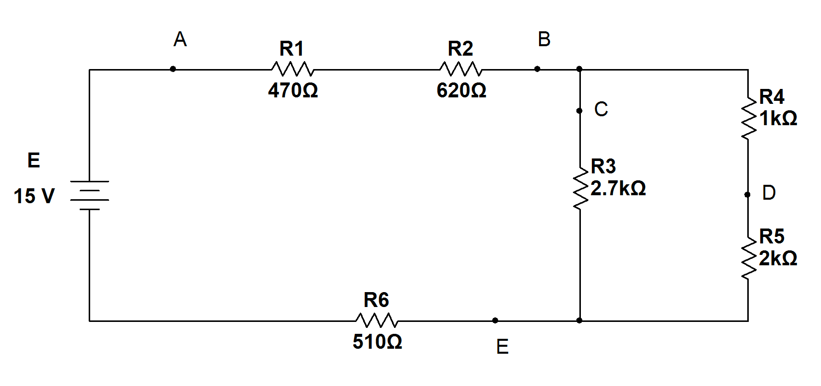

Study Figure. 1 and do the following calculations:

Table 1:

|  |
| --- |
| Rp = 1.421 kΩ |
| Rt = 3.021 kΩ |
| Ia = 4.965 mA |
| Ic  = 2.613 mA |
| Id  = 2.351 mA |

|  |  |
| --- | --- |
| R1: 470Ω | V1 = 2.333 (V) |
| R2: 620Ω | V2 = 3.078 (V) |
| R3: 2.7kΩ | V3 = 7.055 (V) |
| R4: 1kΩ | V4 = 2.351 (V) |
| R5: 2kΩ | V5 = 4.702 (V) |
| R6: 510Ω | V6 = 2.532 (V) |
|  | Vsum = 14.996 (V) |

Note: Vsum excluding R3 since they are in parallel.

1. Calculate the total resistance (Rp) of the two parallel branches (R3// (R4+R5)). Record your result in Table 1.

­­ R­4 + R5 = 3.0kΩ

R­p = 1/(1/+2.7k+1/3.0kΩ) = 1.421kΩ

1. Calculate the total resistance (Rt) as seen by the source E. Record your result in Table 1.

Rt­ = 1421+470+510+620 =3.021kΩ

1. From (b) and using Ohm’s Law, calculate the source current Ia (flowing through point A). Record your result in Table 1.

V = IR

I­a­­­­­­ = 4.965 mA

1. With Ia and using Current Divider Rule, determine the current Ic and Id through the branches. Record your result in Table 1.

Ic = ­­ Ia

Id = ­­ Ia

Ic = 2.613 mA

Id = 2.351 mA

1. With the above currents, calculate the voltage drop across each resistor. Record your result in Table 1.
2. With the help of Kirchhoff’s Voltage Law, complete the following formula with symbols as well as numbers from Table 1:

***E = V1 + V2 + V4 +*** V5 +V6 ***= 2.333+ 3.078 + 2.351+ 4.702 +2.532 = 14.996 (V)***

1. With the help of Kirchhoff’s Current Law, complete the following formula with symbols as well as numbers from Table 1:

***Ib =2.613+2.351=4.965mA***

**8. MEASUREMENTS:**

**A – Resistance Measurement:**

1. Built the circuit of Fig.1 without the source E attached. Set the DMM to measure resistance (Ω) then measure the resistance Rp of the parallel branch (between B and E) and the total resistance Rt of the whole circuit. Record you results in Table 2.

Table 2:

|  |
| --- |
| Rp = 1.411 kΩ |
| Rt = 3.002 kΩ |
| V­S ­= 15.001 V |

1. Compare Table 2 results to those of Table 1.

**B – Voltage Measurement:**

1. Locate the **fixed 15V** source on the power supply then connect this source to the resistor network. Set the DMM to measure DC voltage then measure the source voltage E and all voltage drops across the resistors. Record your results in Table 3:

Table 3:

|  |  |  |  |  |
| --- | --- | --- | --- | --- |
| Resistance base (Ω)_ | Resistance measured (Ω) | Resistance 5% range(Ω) | Voltage drops  Predicted (V) | Voltage drops  measured (V) |
| R1: 470 | R1: 466.98 | 446.500 - 493.500 | V1 = 2.333 | V1 = 2.333 |
| R2: 620 | R2: 619.1 | 589.00 - 651.000 | V2 = 3.078 | V2 = 3.095 |
| R3: 2.7k | R3: 2.679k | 2565.000 – 2835.000 | V3 = 7.055 | V3 = 7.055 |
| R4: 1k | R4: 987.30 | 950.000 – 1050.000 | V4 = 2.351 | V4 = 2.339 |
| R5: 2k | R5: 1.987k | 1900.000 – 2100.000 | V5 = 4.702 | V5 = 4.710 |
| R6: 510 | R6: 503.25 | 484.500 – 535.500 | V6 = 2.532 | V6 = 2.515 |

1. Compare these results to those calculated in Table 1.
2. Identify the measured value that is most different from the calculated one. Try to find an explanation (and correction) for this.

**C – Current Measurement:**

1. Set the DMM to measure DC current then break the circuit to measure currents at points A, C and D (remember to reconnect the break after each measurement!)

Table 4:

|  |
| --- |
| Ia = 4.999 mA |
| Ic = 2.630 mA |
| Id = 2.368 mA |
| I­b = ­­­5.000 mA |
| I­e = ­­4.999 mA |

1. Compare the results to those of Table 1.

**D – Multisim Simulation:**

1. Create a Multisim circuit (similar to Fig. 1) with:
2. One Voltmeter to measure source voltage E, one for the parallel branch   
   (across R4+R5), and one for each resistor R1, R2, R6.
3. Insert Ammeters to measure currents at points A, B, C, D, E.

**9. LAB REPORT REQUIREMENT:**

Your team’s Lab Report should contain the followings:

**A Cover Page** with Lab Number, Lab Title, Team members’ Names and Date.

**Result Pages** with:

**A- Resistance Measurements:**

Results:

Show a copy of Table 2

Discussions:

* 1. Answer 8(b).
  2. Are the techniques you use to calculate Rp and Rt accurate?

**B- Voltage Measurements:**

Results:

Show a copy of Table 3.

Discussions:

* 1. Answer 8(d) and 8(e). Compare also with Multisim voltages.
  2. When you verify Kirchhoff’s Voltage Law (Pre-Lab part (f)), what voltage do you use for the parallel branch? And why?

**C- Current Measurements:**

Results:

Show a copy of Table 4

Discussions:

* 1. Answer 8(g). Compare also with Multisim currents.
  2. Did the Current Divider Rule work in this case?

**D- Conclusion:** (*it helps to compare your prelab with measured results*)

1. What conclusion can you make about Kirchhoff’s Voltage Law for a series-parallel circuit?
2. What conclusion can you make about Kirchhoff’s Current Law for a series-parallel circuit?
3. Are all the Lab objectives met? Explain if some are not.

**Appendix:** Attach a printout of **Multisim** simulation and all **Pre-Lab calculations**.

Measurements: